Paulo Intermediate School 75
Proceed as if limits to our own ability do not exist
455 Huguenot Avenue
Staten Island, NY 10312
Tel: 718.701.6343
Fax: 718.701.6351

Kenneth Zapata
Principal

September 13, 2023

Dear Parent/Guardian:

We would like to extend an invitation for you to attend our virtual Curriculum Conference/ Parent Information Night which is scheduled for Thursday, September 21, 2023. This conference is designed to give insight into the curriculum and instruction that your child will receive throughout the year. This important event will allow you to meet the teachers and open lines of communication to ensure a successful year in the academic, and social/ emotional development of your child. You will hear from the teachers regarding the curriculum in all subject areas, and they will provide a brief overview of the topics that will be taught, as well as the resources that will be used throughout the year.

Teachers will also inform you about the expectations in their individual classes regarding such things as classroom routines, homework, and assessments. We are prepared to be as thorough as possible in the allotted time, but due to time constraints, limited time will be available for individual questions. Parents with specific concerns regarding their own children should make appointments to speak with the teachers at a later date. Questions can also be emailed to our staff who will respond in a timely manner.

On this evening, you will have the opportunity to attend one of the two identical sessions and follow your child’s Monday schedule. Parents will log into their children’s Google Classrooms and join the Meets at the times that correspond to the student’s class periods. It is encouraged for your child to attend these conferences with you to help navigate the Google Classrooms, but if that is not possible, please ensure that you have access to his/her Google Classrooms prior to that evening. The session times are as follows:

Schedule I  4:30 PM – 6:00 PM | Schedule II  6:00 PM – 7:30 PM
Advisory – Introduction by Mr. Zapata – The link will be emailed on 9/21.  4:30 PM – 4:38 PM | Advisory – Introduction by Mr. Zapata – The link will be emailed on 9/21.  6:00 PM – 6:08 PM
Period 1  4:40 PM – 4:48 PM | Period 1  6:10 PM – 6:18 PM
Period 2  4:50 PM – 4:58 PM | Period 2  6:20 PM – 6:28 PM
Period 3  5:00 PM – 5:08 PM | Period 3  6:30 PM – 6:38 PM
Period 4  5:10 PM – 5:18 PM | Period 4  6:40 PM – 6:48 PM
Period 5  5:20 PM – 5:28 PM | Period 5  6:50 PM – 6:58 PM
Period 6  5:30 PM – 5:38 PM | Period 6  7:00 PM – 7:08 PM
Period 7  5:40 PM – 5:48 PM | Period 7  7:10 PM – 7:18 PM
Period 8  5:50 PM – 5:58 PM | Period 8  7:20 PM – 7:28 PM
5:58 –  Dismissal of Schedule I | 7:28 –  Dismissal of Schedule II

You can access your child’s schedule on NYCSA (New York City Schools Account), and we ask that you follow the “Monday” course schedule. The most effective way to ensure a student’s success is through a collaborative partnership between the teachers, administration, and parents. We look forward to seeing you as we prepare for an exciting new year.

Sincerely,
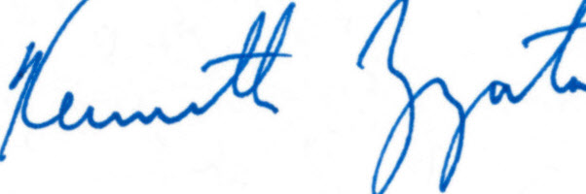
Mr. Kenneth Zapata
Principal

